|  |
| --- |
| Submitted By:  Bishal Pandey  Roll no: 17  A assignment submitted to  Mr. Biplab Dhakal  In partial fulfillment of internal Assignment  BICTE 1st Semester  C:\Users\HP\AppData\Local\Microsoft\Windows\INetCache\Content.Word\Screenshot 2023-04-20 214228.png At  SUNDARHARAINCH-12, MORANG |

|  |
| --- |
| **Laboratory Practical Report**  **of**  **Programming Concept with C**  **Submitted To**  **TRIBHUVAN UNIVERSITY**  **In Partial Fulfillment of the Requirements of the course**  **BICTE 1st Semester**  **Submitted By**  **Full Name: Bishal Pandey**  **Symbol No.: 79214007**  **T.U. Regd. No.: 9-2-214-51-2022**  **Under the guidance of**  **Mr. Biplab Dhakal**  **Faculty Member, BICTE Program**  **Sukuna Multiple Campus**  **SUKUNA MULTIPLE CAMPUS**  **Sundarharaincha, Morang, Nepal**  **2080** |
| **CERTIFICATE**  **This is to certify that the Laboratory Practical Report**  **of**  **Programming concept with C**  **( ICT ED 416)**  **In Partial Fulfillment of the Requirements of the course**  **BICTE 1st Semester**  **Submitted By**  **Full Name: Bishal Pandey**  **Symbol No.: 79214007**  **T.U. Regd. No.: 9-2-214-51-2022**  **is a bonafide record of experiments carried out by him/her under by guidance.**  **_______________**  **Mr. BIplab Dhakal**  **Faculty Member**  **Sukuna Multiple Campus**  **Sundarharaincha-12, Morang**  **(Internal Examiner)**  **Submitted for the Final Examination on : 2080/ /**  **(External Examiner)** | |

Table of contents

|  |  |  |
| --- | --- | --- |
| **S. No.** | Activities | **Page No.** |
| 1 | write a C program to find the GCD of two number using loop. |  |
| 2 | Write a calculator program in C language to do simple operations like addition, subtraction, multiplication and division. Use switch statement in your program. |  |
| 3 | write a c program to find cube of a number using Function. |  |
| 4 | write a c program to find greatest among 10 number using array. |  |
| 5 | write a c program that computes the size of int, float, double and char variables. |  |
| 6 | write a c program to concatenates two strings with and without strcat() function. |  |
| 7 | write a c program that display the Fibonacci series using recursion. |  |
| 8 | write a c program to swap the value of two variable using pointer. |  |
| 9 | write a c program to red and display a text from file. |  |
| 10 | write a c program to check whether a number is prime or composite using function. |  |

1. **write a c program to find the GCD of two number using loop.**

#include <stdio.h>

int gcd(int a, int b) {

if (a == 0) return b;

if (b == 0) return a;

while (a != b) {

if (a > b) a = a - b;

else b = b - a;

}

return a;

}

int main() {

int x, y;

printf("Enter two numbers: ");

scanf("%d %d", &x, &y);

printf("The GCD of %d and %d is %d\n", x, y, gcd(x, y));

return 0;

}

output

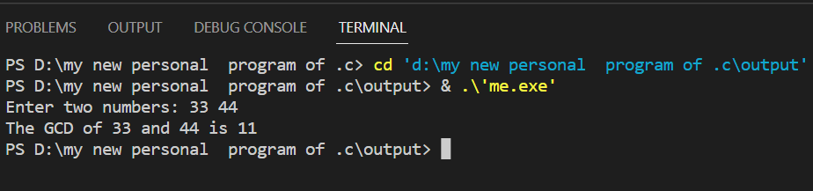

1. **write a calculator program in C language to do simple operations like addition, subtraction, multiplication and division. use switch statement in your program.**

**#include <stdio.h>**

**int main() {**

**double a, b, result;**

**char op;**

**printf("Enter the expression (a op b): ");**

**scanf("%lf %c %lf", &a, &op, &b);**

**switch (op) {**

**case '+':**

**result = a + b;**

**break;**

**case '-':**

**result = a - b;**

**break;**

**case '*':**

**result = a * b;**

**break;**

**case '/':**

**if (b == 0) {**

**printf("Error: Division by zero\n");**

**return 1;**

**}**

**result = a / b;**

**break;**

**default:**

**printf("Error: Invalid operator\n");**

**return 1;**

**}**

**printf("%lf %c %lf = %lf\n", a, op, b, result);**

**return 0;**

**}**

output

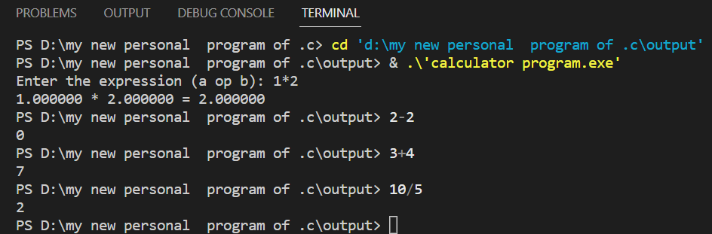

1. **write a c program to find cube of a number using function.**

#include <stdio.h>

double cube(double x) {

return x * x * x;

}

int main() {

double n;

printf("Enter a number: ");

scanf("%lf", &n);

printf("The cube of %lf is %lf\n", n, cube(n));

return 0;

}

output

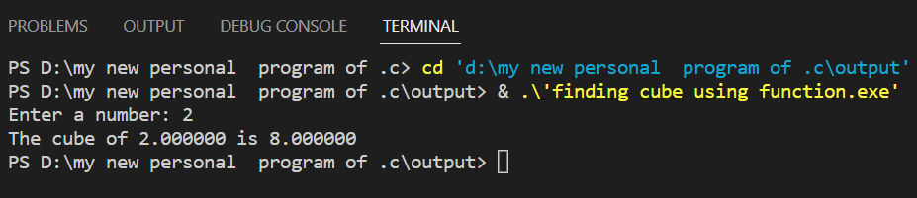

1. **write a c program to find greatest among 10 number using array.**

**#include <stdio.h>**

**int main() {**

**int arr[10];**

**int max = -2147483648;**

**int i = 0;**

**printf("Enter 10 numbers: ");**

**for (i = 0; i < 10; i++) {**

**scanf("%d", &arr[i]);**

**}**

**for (i = 0; i < 10; i++) {**

**if (arr[i] > max) {**

**max = arr[i];**

**}**

**}**

**printf("The greatest among 10 numbers is %d\n", max);**

**return 0;**

**}**

**output**

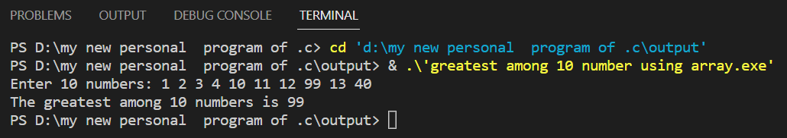

1. **write a c program that computes the size of int, float, double and char variable.**

**#include <stdio.h>**

**int main()**

**{**

**int i;**

**float f;**

**double d;**

**char c;**

**printf("Size of int: %ld bytes\n", sizeof(i));**

**printf("Size of float: %ld bytes\n", sizeof(f));**

**printf("Size of double: %ld bytes\n", sizeof(d));**

**printf("Size of char: %ld bytes\n", sizeof(c));**

**return 0;**

**}**

**output**

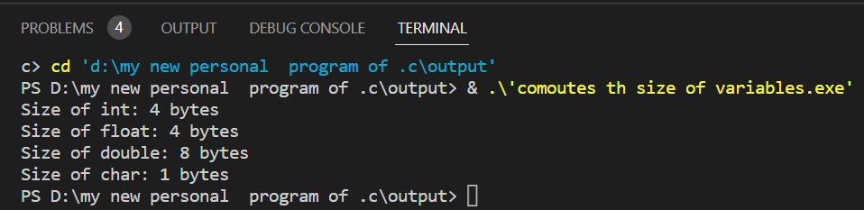

1. **write a c program to concatenates two strings with and without strcat() function.**

**#include <stdio.h>**

**#include <string.h>**

**int main()**

**{**

**char s1[20] = "Hello";**

**char s2[20] = "World";**

**strcat(s1, s2);**

**printf("Concatenated with strcat(): %s\n", s1);**

**strcpy(s1, "Hello");**

**int i = strlen(s1);**

**int j = 0;**

**while (s2[j] != '\0')**

**{**

**s1[i] = s2[j];**

**i++;**

**j++;**

**}**

**s1[i] = '\0';**

**printf("Concatenated without strcat(): %s\n", s1);**

**return 0;**

**}**

**output**

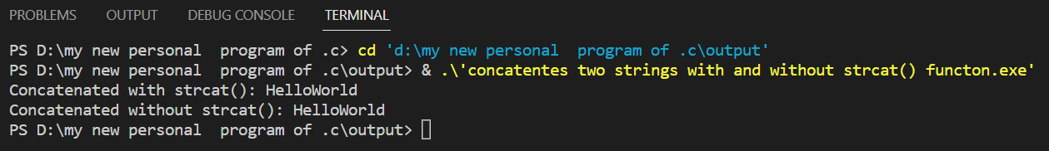

1. **write a c program that display the Fibonacci series using recursion.**

**#include <stdio.h>**

**int fib(int n)**

**{**

**if (n == 0)**

**return 0;**

**if (n == 1)**

**return 1;**

**return fib(n-1) + fib(n-2);**

**}**

**int main()**

**{**

**int n = 10;**

**printf("Fibonacci series of %d terms:\n", n);**

**for (int i = 0; i < n; i++)**

**{**

**printf("%d ", fib(i));**

**}**

**printf("\n");**

**return 0;**

**}**

**output**

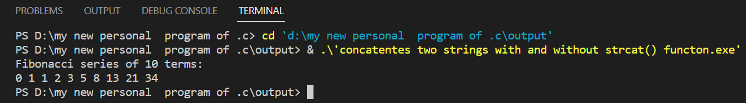

1. **write a c program to swap the value of two variable using pointer.**

**#include <stdio.h>**

**void swap(int *a, int *b)**

**{**

**int temp = *a;**

**\*a = *b;**

**\*b = temp;**

**}**

**int main()**

**{**

**int x = 10;**

**int y = 20;**

**printf("Before swapping: x = %d, y = %d\n", x, y);**

**swap(&x, &y);**

**printf("After swapping: x = %d, y = %d\n", x, y);**

**return 0;**

**}**

**output**

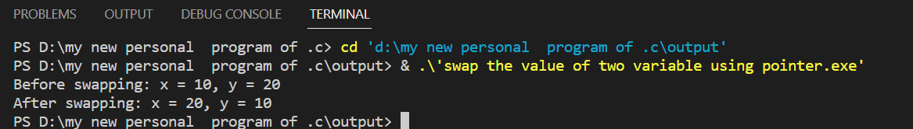

1. **write a c program to read and display a text from file.**

**#include <stdio.h>**

**int main()**

**{**

**FILE *fp = NULL;**

**char buffer[100];**

**fp = fopen("test.txt", "r");**

**if (fp == NULL)**

**{**

**printf("Error opening the file.\n");**

**return -1;**

**}**

**printf("The text in the file is:\n");**

**while (fgets(buffer, 100, fp) != NULL)**

**{**

**printf("%s", buffer);**

**}**

**printf("\n");**

**fclose(fp);**

**return 0;**

**}**

**output**

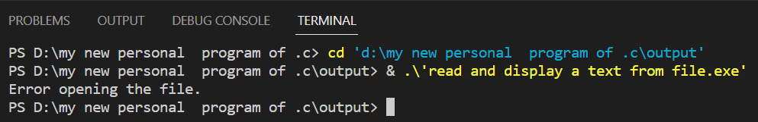

1. **write a c program to check whether a number is prime or composite using fuction.**

**#include <stdio.h>**

**#include <math.h>**

**int is_prime(int n) {**

**if (n < 2) {**

**return 0;**

**}**

**if (n == 2 || n == 3) {**

**return 1;**

**}**

**if (n % 2 == 0 || n % 3 == 0) {**

**return 0;**

**}**

**int limit = sqrt(n);**

**for (int i = 5; i <= limit; i += 2) {**

**if (n % i == 0) {**

**return 0;**

**}**

**}**

**return 1;**

**}**

**int main() {**

**int num;**

**printf("Enter a number: ");**

**scanf("%d", &num);**

**if (is_prime(num)) {**

**printf("%d is a prime number.\n", num);**

**} else {**

**printf("%d is a composite number.\n", num);**

**}**

**return 0;**

**}**

**output**

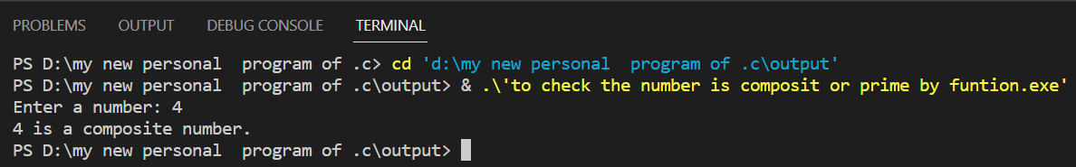

**"Thank you"**